Managing Attendance at Events

Logging Attendance:

- One committee member should be in charge of logging attendance, usually the COVID officer.

- Attendance should be logged into the system as attendees arrive and attendance must be logged by midnight on the day of the event or activity.
- Pre-booking should be used for events. It is not necessary to use the pre-booking feature for regular activities where the same members show up every week eg. training, or committee meetings.
- If you are using pre-booking this must close an hour before the event. However it can close earlier than that.
- On the committee page a box will open to log attendance:
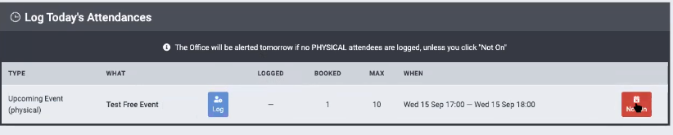
- If the event/activity is cancelled, the red “not on” button should be clicked.
- The blue button logs attendees as they arrive, once it is within an hour of the event. When this button is clicked it brings you to the attendance log page. Where you can see the current and past events:
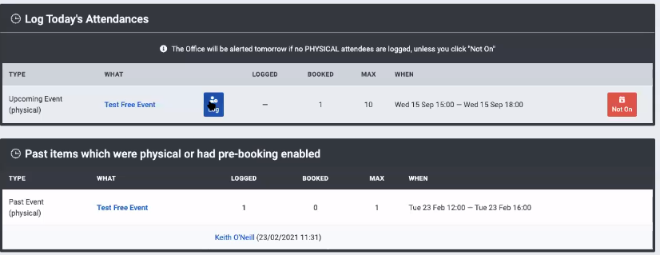
- If the event has pre-booking enabled you can click on the person’s name as they arrive and they are logged into the event. This works very well on mobile phones. When you tap on the person’s name it will turn green to show they are logged in.
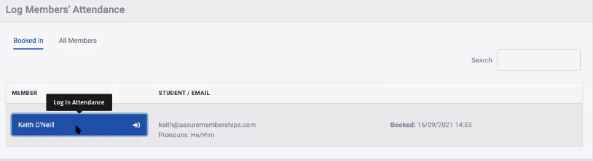
- If pre-booking is not enabled, click on all members and all members will be listed. The search box can be used to find names.
- Once you start logging people in there is a facility to log them out again if required.
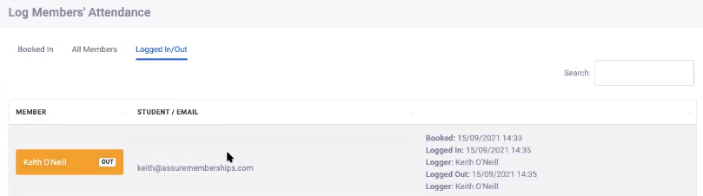
- It is a requirement to have all attendees logged into events and activities

